**Where Can I Find Goal Seek in Excel?**

1. Open Excel and navigate to the “Data” tab.
2. Look for the “Forecast” or “What If Analysis” group.
3. Click the “What If Analysis” button.
4. Select “Goal Seek” from the drop-down menu.

**Steps to Use Goal Seek Excel:**

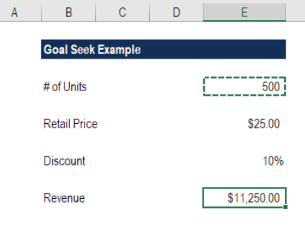

1. When the dialog box appears (as shown below) make “Set cell” equal to the revenue cell (E10)
2. Set “To value” equal to the output you want to achieve (type the number in)
3. Set “By changing cell” equal to the assumption you want to solve for (# of units, or cell E4)
4. Press OK

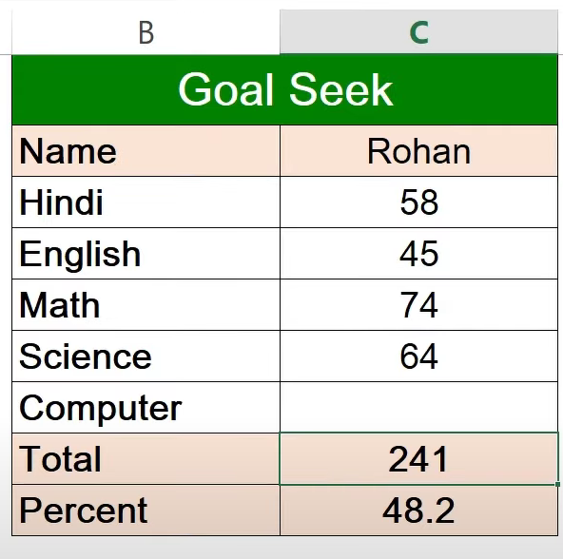

1. How many marks does this Student need to score 300 total marks? Find Out with Goal Seek.
2. How many marks does this Student need to score 65 percent? Find Out with Goal Seek.

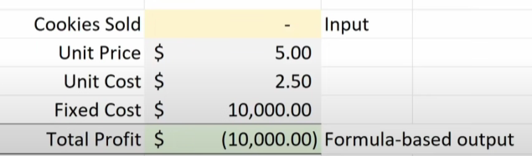

1. How many cookies do I this shop needs to sell to recover cost?
2. How many cookies do this shop needs to sell to become a cookie millionaire?
3. How many cookies do this shop needs to sell to become a cookie multi-millionaire?